H.T No
Regulations:
A18

Sreenidhi Institute of Science and Technology
(An Autonomous Institution)
Code No: 7A304 Date: 28-Oct-2020 (FN)

B.Tech II-Year I-Semester External Examination, October - 2020 (Supplementary)
ELECTRICAL CIRCUITS AND NETWORKS – II (EEE)

Time: 2 Hours Max.Marks:70

Note: a) No additional answer sheets will be provided.
b) All sub-parts of a question must be answered at one place only, otherwise it will not be valued.
c) Missing data can be assumed suitably.

ANSWER ANY 5 OUT OF 8 QUESTIONS. EACH QUESTION CARRIES 14 MARKS.

1. | a) | Derive the relationship between a line voltage and phase voltage related to a star connected load. | [7M]
 | b) | Each phase of a balanced star connected load consists of R=10Ω and C=10µF. calculate the line current and total real and reactive powers when a symmetrical 400V, 50Hz, 3-phase supply is applied to it. If two watt meters are employed to measure total power, what will be the readings of the two watt meters. | [7M]
2. | a) | Explain the transient response of R-L-C Series circuit excited by DC Source.(Step response of R-L-C series circuit).Use differential equation method. | [7M]
 | b) | Find the expression for the current in a series RLC circuit fed by a DC voltage of 20V with R=4Ω, L=1H and C=1/4 F. Assume initial conditions to be zero. | [7M]
3. | a) | Write the necessary conditions for transfer functions. | [7M]
 | b) | Draw the pole zero diagram for the given network function I(s) and hence obtain i(t).  I(s) = | [7M]
4. | a) | Derive the relation to express Z-parameters interms of Y-parameters and Y-parameters interms of Z-parameters. | [7M]
 | b) | Find transmission parameters of the network shown in the figure.  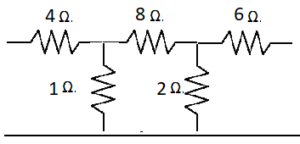 | [7M]
5. | a) | Design constant-k prototype LPF with necessity equations. | [7M]
 | b) | Design constant-k band pass filter with necessity equations | [7M]
6. | a) | Calculate the Fourier series for the function shown in below figure.  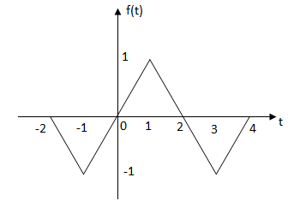 | [7M]
 | b) | Write Fourier transform of a train of impulse. | [7M]
7. | a) | What are the advantages of a three phase system? | [7M]
 | b) | Find the current in a series R-L circuit having R=2Ω and L=10H while a DC voltage of 100V is applied. What is the value of this current after 5 sec. of switching on? | [7M]
8. | a) | Derive the condition of symmetry for z-parameters and y-parameters. | [7M]
 | b) | What is filter? Define pass band, stop band and cut off frequency. | [7M]

-- 00 -- 00 –

